Mark's Dilemma
Bringing a New Product to Market,
A Case Study

Larry E. Watkins, PhD, CPA
College of Business Administration
Northern Arizona University
Box 15066
Flagstaff, AZ 86011
Tel: (928) 523-7368
larry.watkins@nau.edu

and

Roxanne Stell, PhD
College of Business Administration
Northern Arizona University
Box 15066
Flagstaff, AZ 86011
Tel: (928) 523-7404
roxanne.stell@nau.edu

BACKGROUND

Mark Thatcher sat by the side of the fast-flowing Colorado River deep in the Grand Canyon immersed in thought. It was appropriate that this was the location he had chosen to make one of the most important decisions of his business life. After all, it was the five years he spent as a guide/boatman on this very river that had given him the idea for his sport sandal. He had experienced first-hand the difficulties of wearing shower sandals (“flip-flops”) in an environment characterized by mud and swift water. And “sneakers” didn’t work much better. Although they usually stayed on the foot, lack of traction on wet surfaces, which described the entire raft on a whitewater trip, created a serious hazard for the wearer. Sneakers also never allowed the foot to completely dry which, on eighteen-day Colorado River trips, could lead to serious foot ailments. Mark had identified a need for a special type of footwear and developed a design he hoped would fulfill this need. He had combined the basic idea of a shower sandal with a system that would hold the foot firmly on the “foot-bed” of the sandal. This design consisted of a substantial sole and foot-bed with a unique five point strapping system. The straps were made of a strong nylon webbing material that dried quickly and provided many design options. Velcro was incorporated with the straps to allow for maximum adjustability thus insuring optimum comfort and fit. The design was so unique in fact that Mark had recently been granted a patent (see Figures 1 and 2) for the design. He could envision his new sport sandal creation eliminating the footwear problems long experienced by whitewater boaters while hopefully earning him at least some level of income. He had no idea of the number of these sandals that he might sell but he knew that American Whitewater (a not-for-profit conservation organization) estimated that there were 180,000 whitewater paddlers in the U.S. Mark dreamed of the day that one percent of the athletic footwear market would be sport sandals. If he could sell one-tenth of that in the near future he would be ecstatic. First he had to decide how he would get this idea from the prototype stage that had been sewn at the kitchen table to a production model that hopefully would find its way into specialty outdoor stores.

Only a few months earlier Mark had been a petroleum geologist for CITGO, an oil and gas company located in Tulsa, Oklahoma. But after only two years at CITGO another large petroleum company had acquired them and the bulk of the geologists had been “downsized.” Mark now viewed the loss of that job as a blessing in disguise. He just was not cut out to be a “corporate man.” He loved skiing, surfing, mountain biking and whitewater rafting and kayaking. Mark was also passionate about music and often jammed with friends or simply played alone for his own enjoyment. He was so pleased to be free from the restrictions of his job as a geologist that he had decided that he would choose to be a “bum” if his new role as designer/inventor could not support him.

Since leaving CITGO, Mark had seriously depleted his financial reserves working on his invention and the patent. Although certain that his innovative sandal designed for river rafting and kayaking would be well received by the river community which he knew so well, he was less certain of its probability for financial success. Mark knew that his future and the future of his newly patented idea were dependent upon the decision he was about to make. Having been trained as a scientist, Mark was determined to make a rational decision based on all of the relevant information he had been able to gather. Unfortunately Mark had no business background to guide him. He felt he was out of his element but had no real idea of where to look for assistance in analyzing his alternatives other than his patent attorney.

ALTERNATIVES

Based on conversations with his patent attorney and personal friends Mark believed he had identified his best alternatives for capitalizing on his sandal design. He viewed the alternatives as 1) manufacture the sandals himself, 2) license the patent to an established manufacturer, or 3) sell the intellectual property rights (patent).

MANUFACTURE

Mark had initially leaned toward manufacturing and distributing the sandals via his own company even though he admittedly had no experience in such activities. He knew that manufacturing would require a very large investment in equipment and facilities that he had calculated to be in the neighborhood of $250,000. Another significant sum would be required to hire and train personnel, acquire raw materials inventories, and establish a simple distribution network. He estimated that this would require an additional 150,000 to $250,000. Unfortunately, Mark was down to his last $30,000, which had to provide for his personal living expenses into the foreseeable future. He had approached a few lending institutions but with only a patent and the hope of future sales they were unwilling to provide the necessary funding. He knew from discussions with various professional contacts he had developed while working as a geologist that venture capitalists were also a possibility. However he had been assured that venture capitalists would require a majority interest in the venture thereby gaining control of his intellectual property rights (the patent) and any company that was eventually formed. Mark was hesitant to relinquish control of the concept he had so recently created and to which he was emotionally attached.

LICENSING

Joe, the attorney that advised Mark during the patenting process was also a long-time friend. He had suggested licensing as an alternative that Mark could pursue. Licensing amounted to allowing another company to manufacture the sandals while paying the owner of the patent a royalty for each pair sold. Perhaps an existing company with experience in producing and distributing similar products could be located and enticed into an acceptable licensing agreement. Joe warned Mark that the pitfalls of such agreements were legendary. Control of the production process invariably rested with the licensee (manufacturer) and quality problems were common. This troubled Mark greatly since he knew that the sandals had to be manufactured in such a way as to guarantee the highest standards of quality if he was to have any hope of repeat patronage and brand loyalty from the river guide/boatman segment.

Initially Mark approached Patagonia, Inc. in hopes the premier outdoor clothing and equipment manufacturer would see his sandal as a good fit to their product lines. He was confident that they could provide the high quality manufacturing and exclusive distribution he desired. However, Patagonia's management saw little potential market for Mark's sport sandals and declined to explore an agreement with Mark. Patagonia's rejection was a serious blow to Mark's ego and caused him to question his optimism regarding his sandal design. However, Mark was resilient and soon was looking for licensing candidates again.
Ultimately, Mark was able to interest only one potential licensee that had the requisite manufacturing and distribution experience. Pacifico Manufacturing (Pacifico) was a small manufacturer producing shower and beach sandals (flip-flops) that had expressed limited interest in licensing Mark’s sandal patent. Mark had an uneasy feeling regarding Pacifico that stemmed from their initial refusal to sign a non-disclosure agreement when he first met with them in their southern California plant. The agreement would have prohibited Pacifico from using anything they learned in Mark’s presentation or providing that information to others if Pacifico did not enter into a licensing agreement with Mark. Non-disclosure agreements had long been established as the norm prior to holding such discussions. Pacifico eventually signed the agreement but only after Mark had indicated he was terminating the meeting. That experience led Mark to question the business ethics of Pacifico's management.

SALE OF THE PATENT

The final option that Mark had for capitalizing on his sandal design was to sell his intellectual property rights (the patent) to a company that would produce, modify or abandon the design as they saw fit. Two companies, one an outdoor products manufacturer the other a footwear concern, had expressed interest in such a transaction. These companies had two possible motives for purchasing the patent: first were the potential profits of producing and distributing the sandals, the second was removing the sandals as possible competing products to other footwear lines. Given that two interested parties had been identified, a purchase price of 175,000 to $250,000 had been discussed. Such a sale would considerably reduce the financial stress Mark had been experiencing since his termination from CITGO. But, he was reluctant to lose out on the possibility of his sandal design being wildly successful. However, the saying “a bird in the hand is worth two in the bush” kept running through his thoughts.

CASE QUESTIONS

1) What other information would you want if you were Mark in this situation? How might this information be obtained?

2) Identify the risks and benefits of the three alternatives. Discuss how some of the risks identified might be mitigated.

3) Are there other alternatives that Mark may have failed to identify? If so what are these and what risks are associated with each?

4) If in Mark’s position how would you choose to bring this product to market?
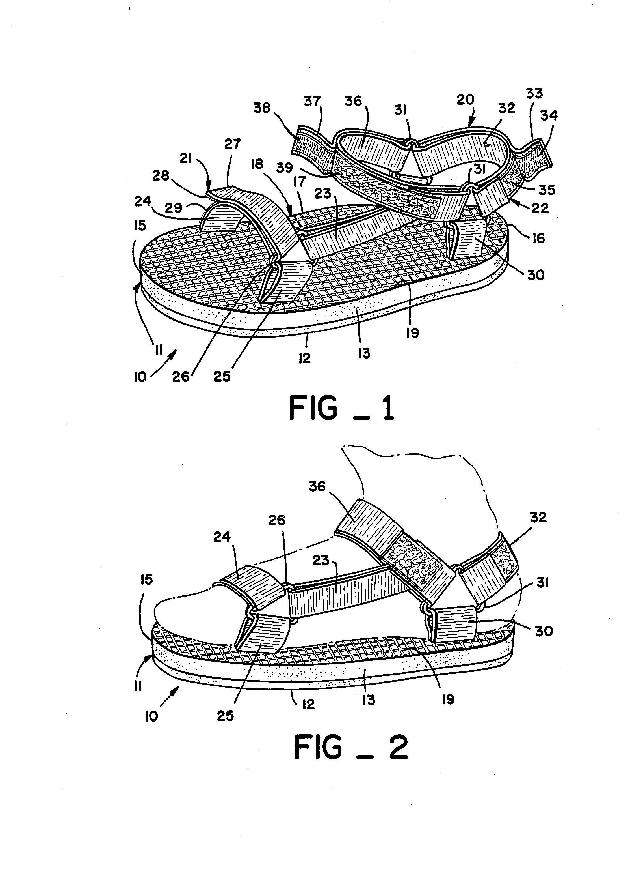
MARK'S DILEMMA ADDENDUM

Assume that you were asked to advise Mark in regard to his pending decision. In your research you were able to acquire the following information: athletic footwear production, shipments, exports, imports, and apparent consumption 24.9 million pairs. Wholesale price of sandals $21.

COST ESTIMATES FOR MANUFACTURING

Rental of 2,000 square feet of warehouse space (minimum size available locally) $.48/sq ft/ month; 3 year lease required. First and last months' rent plus $3,000 deposit required. Minimum leasehold improvements (with a useful life of four years and no residual value) estimated at $7,500.

- Industrial sewing machine* capable of producing 200 sets of strapping per eight hour day $5,400
- Used die cutter* for stamping (cutting) soles from sheet stock $12,500 including set of dies for different sized sandals
- Used vulcanizing equipment* for laminating sandal soles, $9,500
- Utilities and insurance costs estimated at $10,800 per year
- Professional services at $18,000 per year
- Administrative costs $16,800 per year
- Minimum materials inventory required for start-up $22,000
- Manager for the operations (recall Mark has no relevant training or experience) $90,000
- Direct labor per sandal pair $5.28
- Direct materials per sandal pair $6.22

*all equipment is estimated to have a 3 year useful life with no residual value
ADDENDUM QUESTIONS

A1) If Mark decides to manufacture the sandals and wants working capital in an amount adequate to pay three months of operating expenses what amount of cash must he have on hand to start operations? (Assume production and sales are evenly distributed throughout the year and sales levels immediately reach the level at which Mark would be ecstatic, 1/10th of one percent of athletic shoe sales.)

A2) If Mark has to borrow the amount determined in A1 and repay the loan over three years (36 monthly payments) with an interest rate of 1% per month how does that change your response to question A1?

A3) What level of sales must Mark reach to break-even in the first year of operations assuming interest expense of $17,650?

A4) If Mark's sales reach the .001% level (the level at which he would be ecstatic) what would his pre-tax income be for the first year (again assuming interest expense of $17,650)?

A5) If Mark enters into a licensing agreement that provides a $2 per pair royalty, how much would Mark receive the first year if sales reaches the "ecstatic" level immediately?

A6) It appears that manufacturing provides significantly more pre-tax income than licensing. What other considerations might lead Mark toward licensing?

